---------------------------------------------------------------------

-- LAB 18

--

-- copy-paste text about lab from doc file

--

-- Exercise 1

---------------------------------------------------------------------

USE TSQL;

GO

---------------------------------------------------------------------

-- Task 1

--

-- The IT department has provided the following T-SQL code.

--

-- This code inserts two rows into the HR.Employees table. By default, SQL Server treats each

-- individual statement as a transaction. In other words, by default, SQL Server automatically commits

-- the transaction at the end of each individual statement. So in this case the default behavior would be

-- two transactions since you have two INSERT statements. (Do not worry about the details of the INSERT statements

-- because they are only meant to provide sample code for the transaction scenario.)

-- In this example, you would like to control the transaction and execute both INSERT statements inside one transaction.

-- Before the supplied T-SQL code, write a statement to open a transaction. After the supplied

-- INSERT statements, write a statement to commit the transaction. Highlight all of the T-SQL code and execute it.

-- Observe and compare the results that you got with the desired results shown in

-- the file 52 - Lab Exercise 1 - Task 1_1 Result.txt.

-- Write a SELECT statement to retrieve the empid, lastname, and firstname columns from the HR.Employees table.

-- Order the employees by the empid column in descending order. Execute the SELECT statement.

-- Observe and compare the results that you got with the desired results shown in the file 53

-- - Lab Exercise 1 - Task 1_2 Result.txt. Notice the two new rows in the result set.

---------------------------------------------------------------------

CREATE PROCEDURE insertData

AS

Begin

BEGIN TRY

BEGIN TRANSACTION

INSERT INTO HR.Employees (lastname, firstname, title, titleofcourtesy, birthdate, hiredate, address,

city, region, postalcode, country, phone, mgrid)

VALUES (N'Johnson', N'Test 1', N'Sales Manager', N'Mr.', '19700101', '20110101', N'Some Address 18',

N'Ljubljana', NULL, N'1000', N'Slovenia', N'(386) 113322', 2);

INSERT INTO HR.Employees (lastname, firstname, title, titleofcourtesy, birthdate, hiredate, address,

city, region, postalcode, country, phone, mgrid)

VALUES (N'Robertson', N'Test 2', N'Sales Representative', N'Mr.', '19850101', '20110601', N'Some Address 22',

N'Ljubljana', NULL, N'1000', N'Slovenia', N'(386) 553344', 10);

COMMIT TRANSACTION

END TRY

Begin CATCH

SELECT ERROR_MESSAGE() as errMsg,ERROR_SEVERITY() as errSeverity , ERROR_STATE() errState , ERROR_NUMBER() errNumb

ROLLBACK TRANSACTION

END CATCH

END

GO

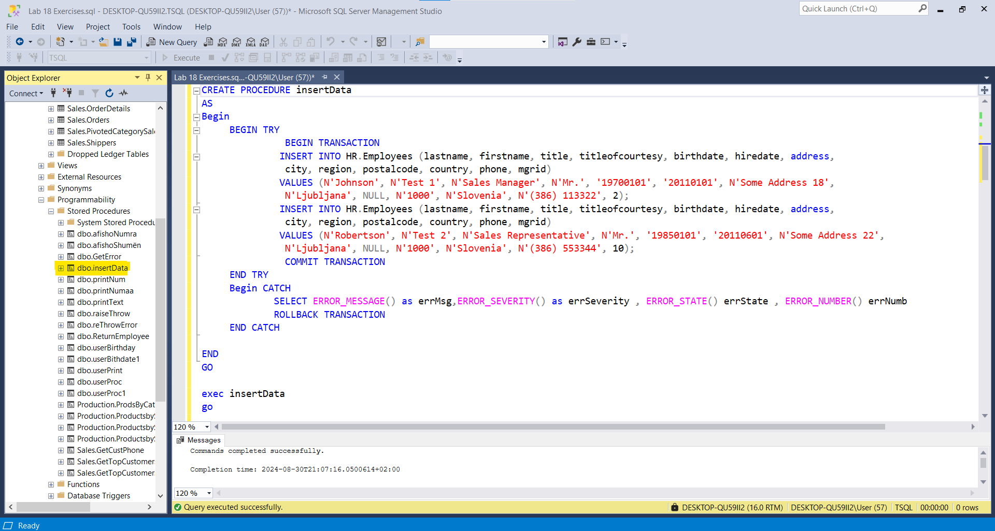

exec insertData(Ekzekutuar 2 here, pra jane shtuar nga 2 , 4 rekorde)

go

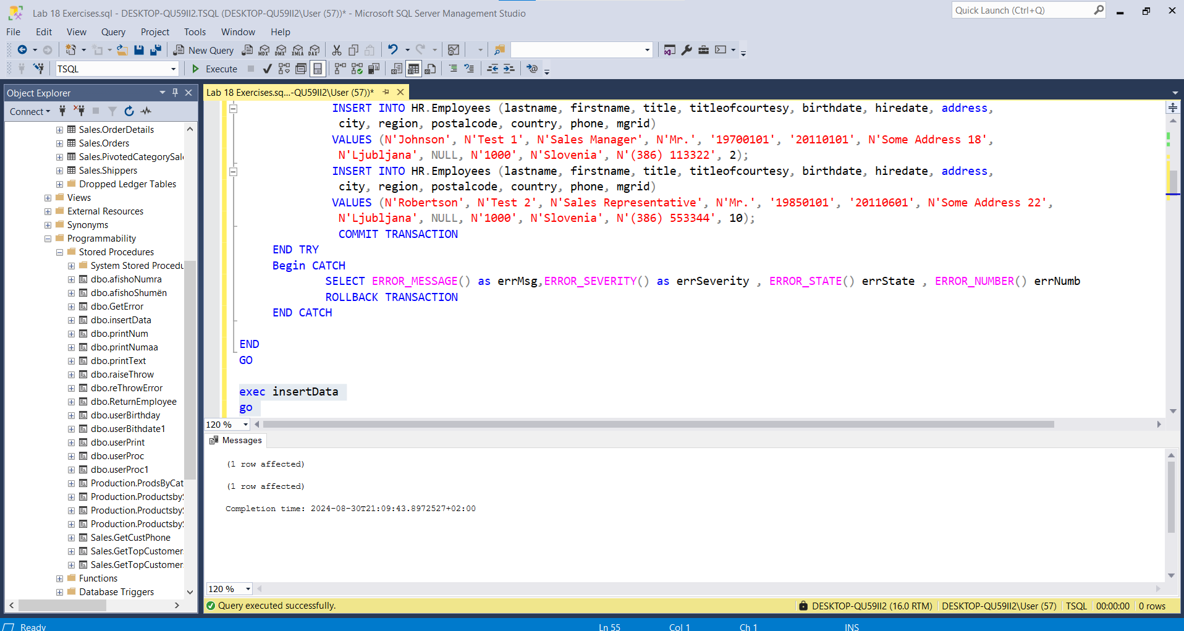

Select * From HR.Employees

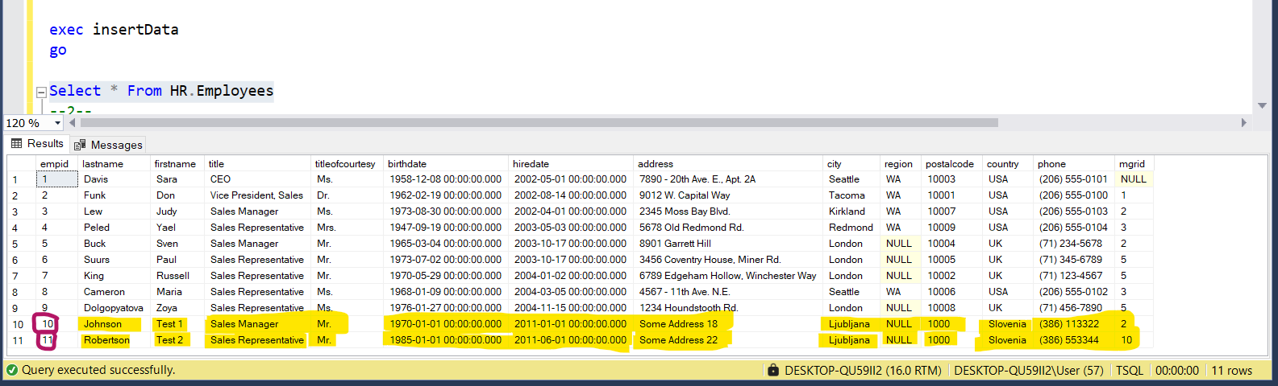

--2--

CREATE PROCEDURE selectEmployeeRecorde(@empId int)

as

BEGIN

begin try

BEGIN TRANSACTION

SELECT e.empid , e.firstname , e.lastname

FROM HR.Employees as e

WHERE e.empid > @empId

ORDER BY e.empid desc

COMMIT TRANSACTION

end try

begin catch

Select ERROR_MESSAGE() AS ERROR_MESSAGE, ERROR_PROCEDURE() AS ERROR_PROCEDURE,ERROR_NUMBER() AS ERROR_NUMBER,

ERROR_SEVERITY() AS ERROR_SEVERITY, ERROR_STATE() AS ERROR_STATE

ROLLBACK TRANSACTION

end catch

END

GO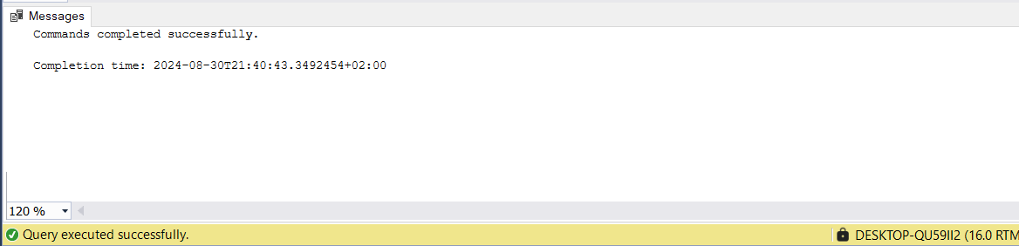

EXEC selectEmployeeRecorde @empId = 0

GO

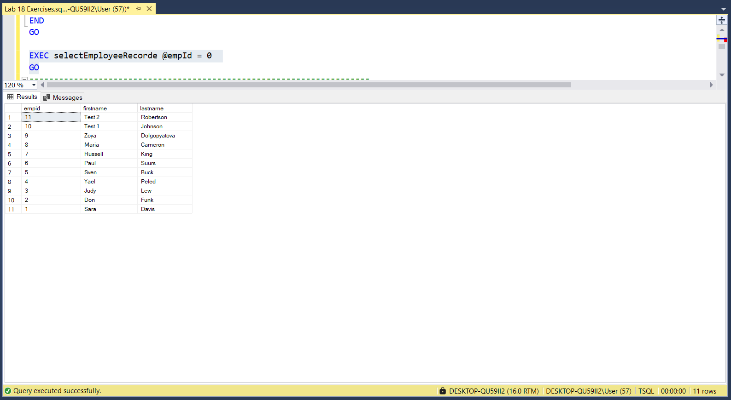

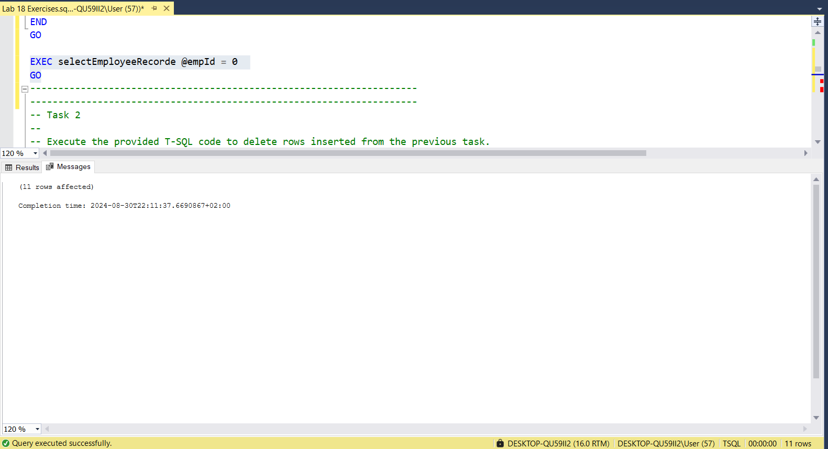

---------------------------------------------------------------------

---------------------------------------------------------------------

-- Task 2

-- Execute the provided T-SQL code to delete rows inserted from the previous

task.

---------------------------------------------------------------------

DELETE HR.Employees

WHERE empid IN (10, 11);

DBCC CHECKIDENT ('HR.Employees', RESEED, 9);

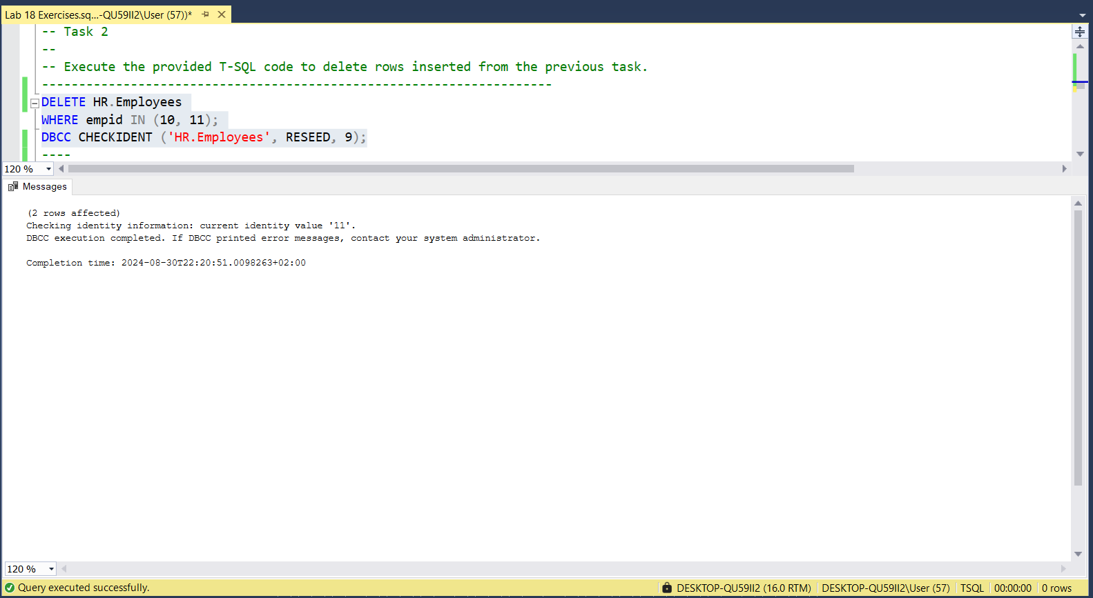

----------------------------

GO

Create procedure deleteEmployee(@EmployeeID INT)

as

BEGIN

BEGIN TRY

BEGIN TRANSACTION

DELETE HR.Employees

WHERE empid=@EmployeeID

DBCC CHECKIDENT ('HR.Employees', RESEED, 9);

COMMIT TRANSACTION

END TRY

BEGIN CATCH

SELECT ERROR_MESSAGE() as ErrorMessage,ERROR_NUMBER() as ERROR_NUMBER,ERROR_PROCEDURE() as ERROR_PROCEDURE ,ERROR_SEVERITY() as ERROR_SEVERITY

ROLLBACK TRANSACTION

END CATCH

END

GO

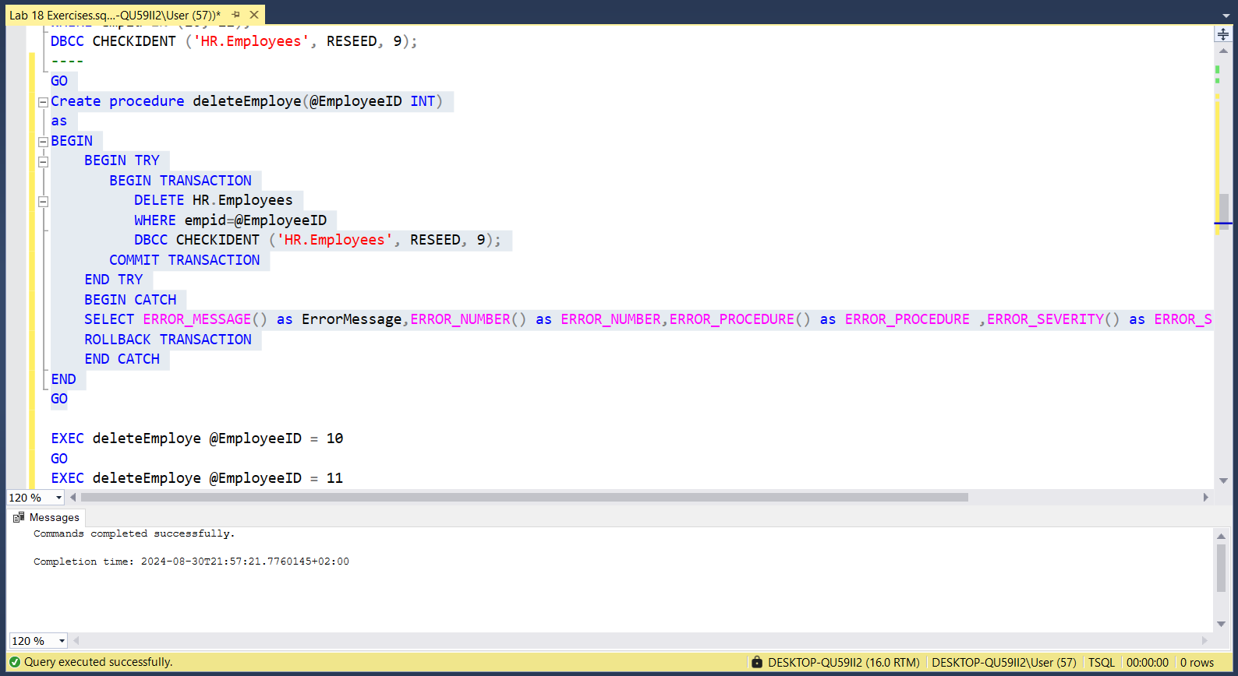

EXEC deleteEmployee @EmployeeID = 10

GO

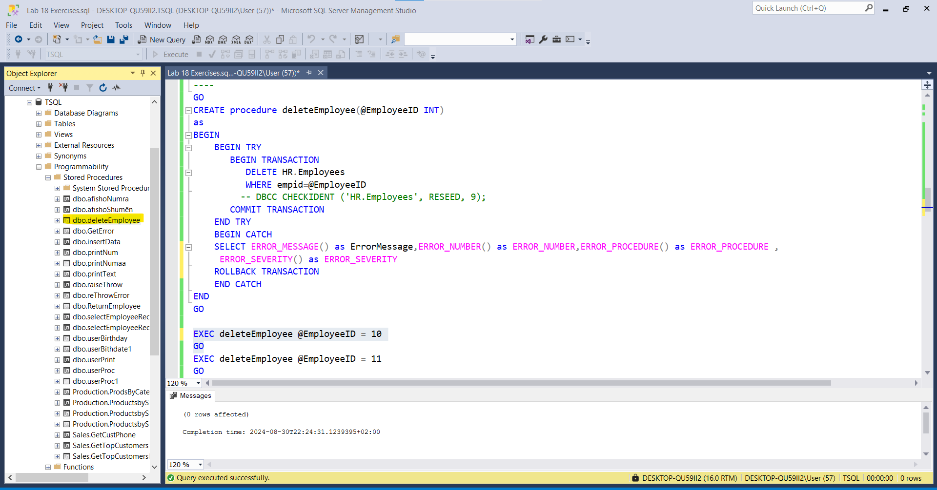

EXEC deleteEmployee @EmployeeID = 11

GO

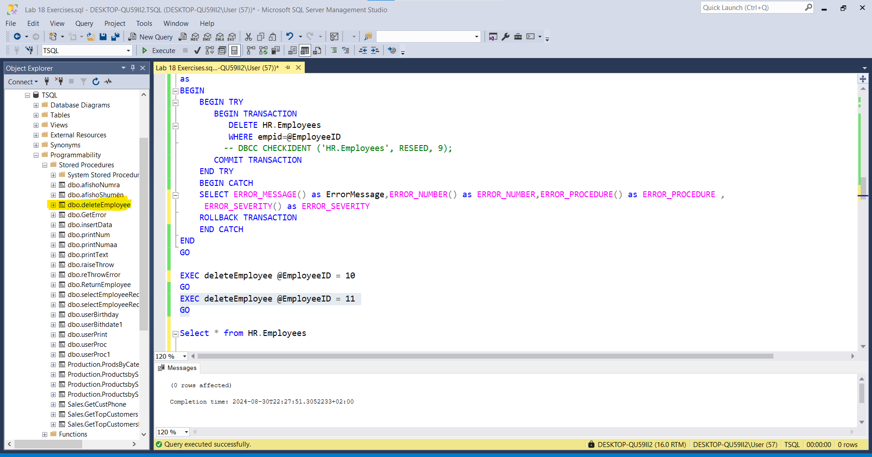

Select * from HR.Employees

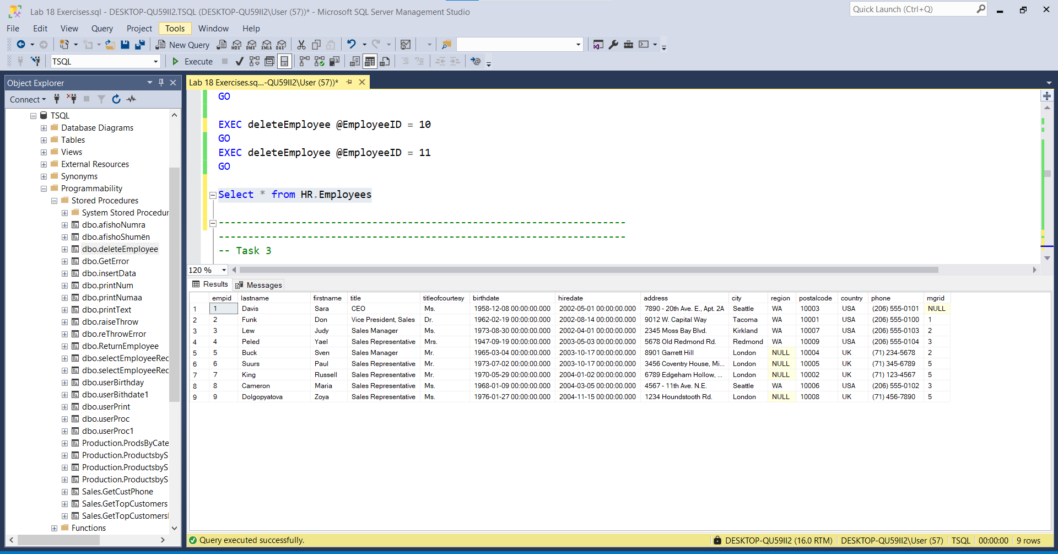

---------------------------------------------------------------------

---------------------------------------------------------------------

-- Task 3

--

-- The IT department has provided T-SQL code (which happens to the same code as in task 1). Before the provided T-SQL code, write a statement to start a transaction.

--

-- Highlight the written statement and the provided T-SQL code, and execute it.

--

-- Write a SELECT statement to retrieve the empid, lastname, and firstname columns from the HR.Employees table. Order the employees by the empid column.

--

-- Execute the written SELECT statement and notice the two new rows in the result set.

--

-- Observe and compare the results that you got with the desired results shown in the file 54 - Lab Exercise 1 - Task 3_1 Result.txt.

--

-- After the written SELECT statement, write a ROLLBACK statement to cancel the transaction. Execute only the ROLLBACK statement.

--

-- Highlight and again execute the written SELECT statement against the HR.Employees table.

--

-- Observe and compare the results that you got with the desired results shown in the file 55 - Lab Exercise 1 - Task 3_2 Result.txt. Notice that the two new rows are no longer present in the table.

---------------------------------------------------------------------

INSERT INTO HR.Employees (lastname, firstname, title, titleofcourtesy, birthdate, hiredate, address, city, region, postalcode, country, phone, mgrid)

VALUES (N'Johnson', N'Test 1', N'Sales Manager', N'Mr.', '19700101', '20110101', N'Some Address 18', N'Ljubljana', NULL, N'1000', N'Slovenia', N'(386) 113322', 2);

INSERT INTO HR.Employees (lastname, firstname, title, titleofcourtesy, birthdate, hiredate, address, city, region, postalcode, country, phone, mgrid)

VALUES (N'Robertson', N'Test 2', N'Sales Representative', N'Mr.', '19850101', '20110601', N'Some Address 22', N'Ljubljana', NULL, N'1000', N'Slovenia', N'(386) 553344', 10);

--***E njëjtë me TASK1

---E njejte me kerkesen ne TASK1

GO

CREATE PROCEDURE insertDatas

AS

Begin

BEGIN TRY

BEGIN TRANSACTION

INSERT INTO HR.Employees (lastname, firstname, title,

titleofcourtesy, birthdate, hiredate, address,

city, region, postalcode, country, phone, mgrid)

VALUES (N'Johnson', N'Test 1', N'Sales Manager', N'Mr.',

'19700101', '20110101', N'Some Address 18',

N'Ljubljana', NULL, N'1000', N'Slovenia', N'(386)

113322', 2);

INSERT INTO HR.Employees (lastname, firstname, title,

titleofcourtesy, birthdate, hiredate, address,

city, region, postalcode, country, phone, mgrid)

VALUES (N'Robertson', N'Test 2', N'Sales

Representative', N'Mr.', '19850101', '20110601', N'Some

Address 22', N'Ljubljana', NULL, N'1000', N'Slovenia',

N'(386) 553344', 10);

COMMIT TRANSACTION

END TRY

Begin CATCH

SELECT ERROR_MESSAGE() as errMsg,ERROR_SEVERITY() as errSeverity , ERROR_STATE() errState , ERROR_NUMBER() errNumb

ROLLBACK TRANSACTION

END CATCH

END

GO

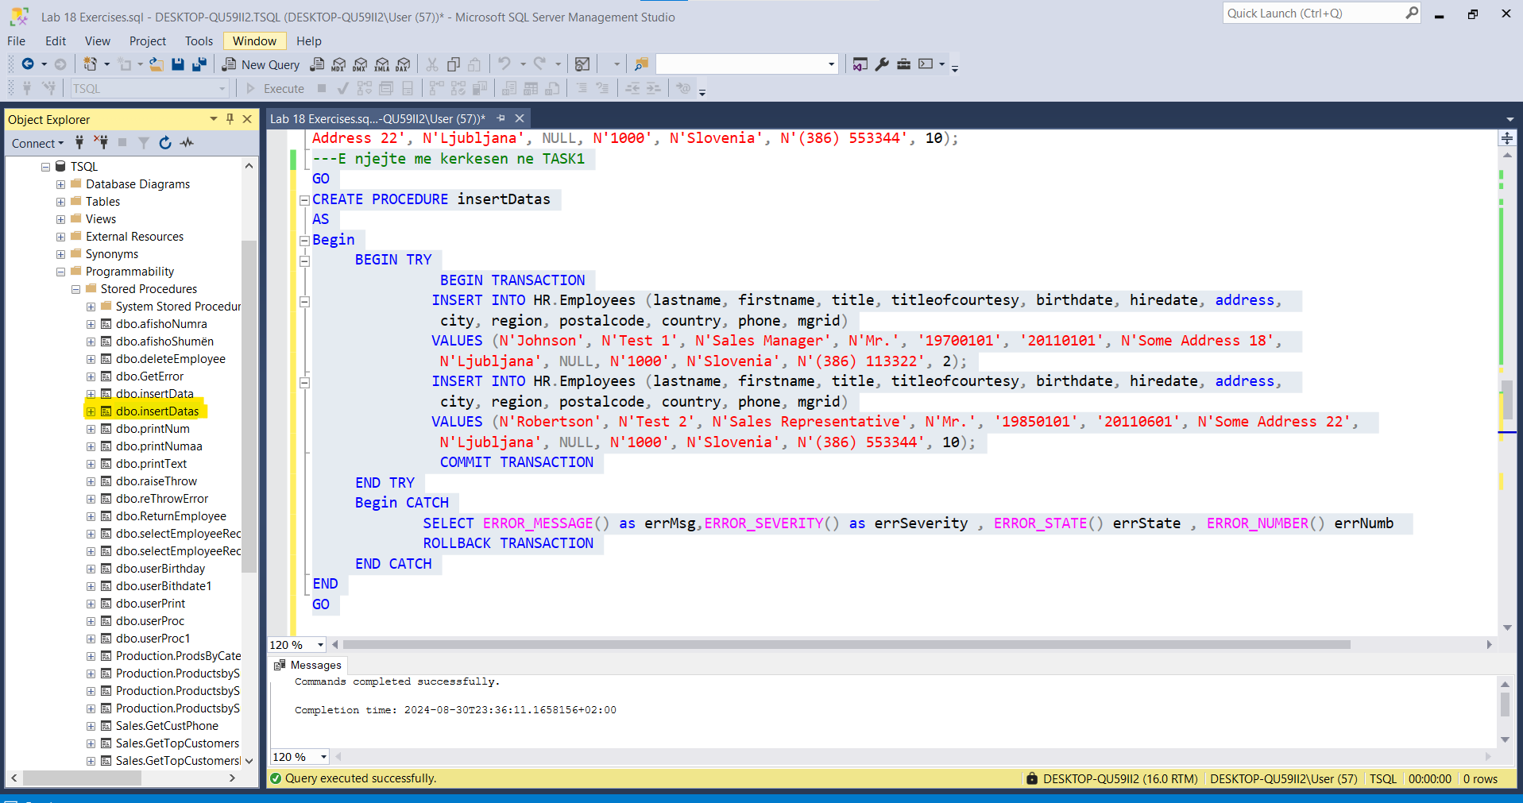

exec insertDatas

GO

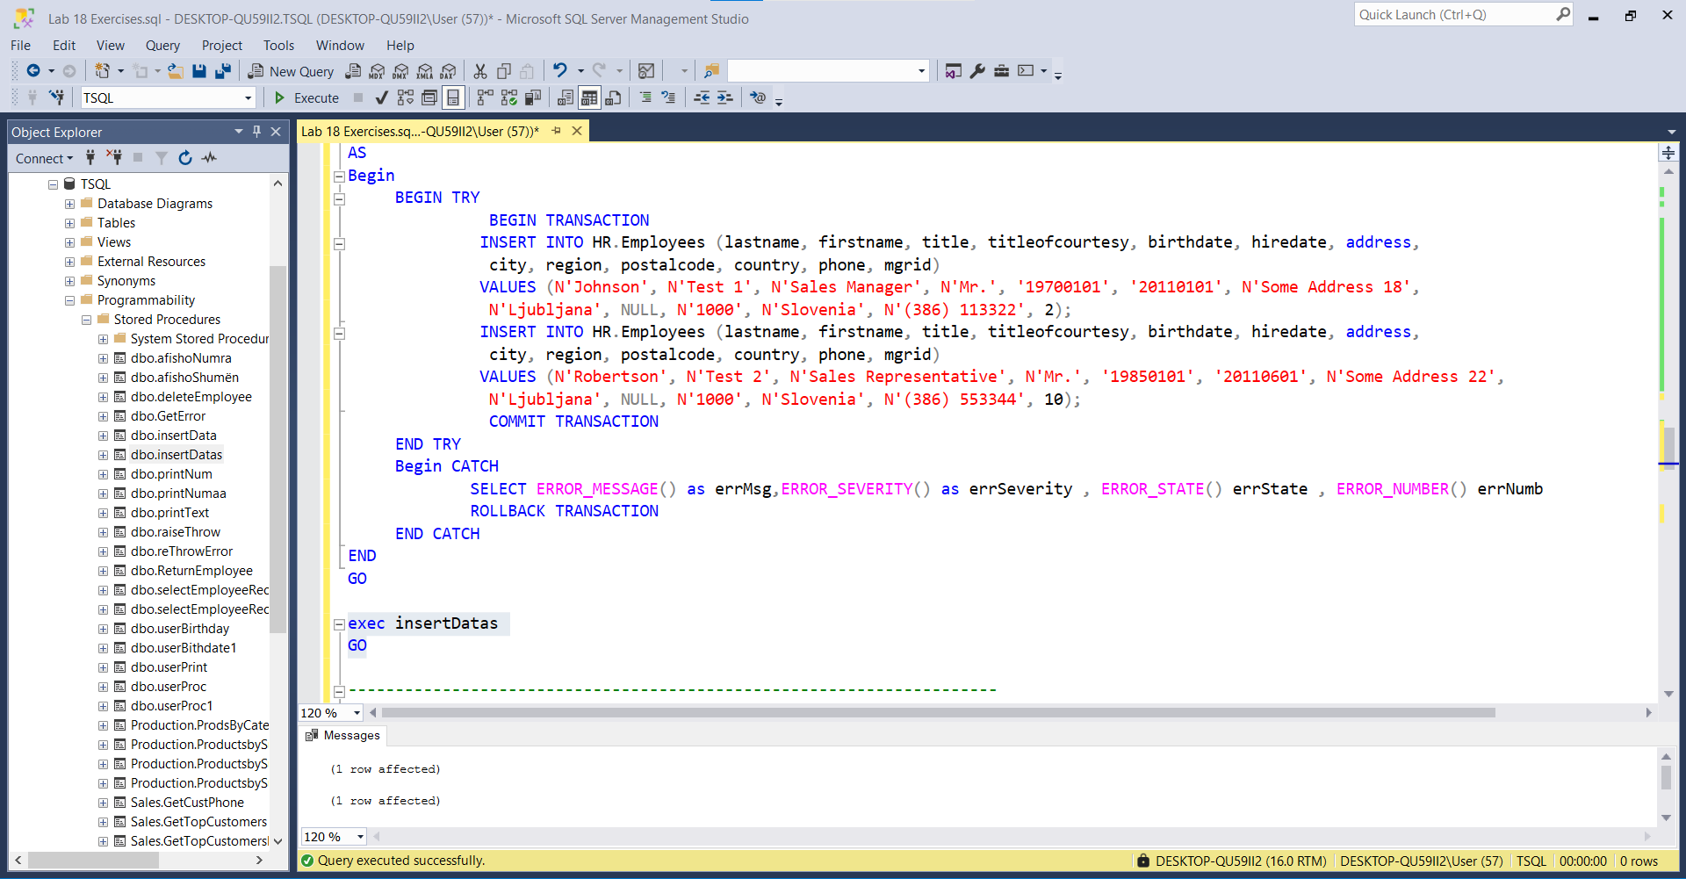

Select * From HR.Employees

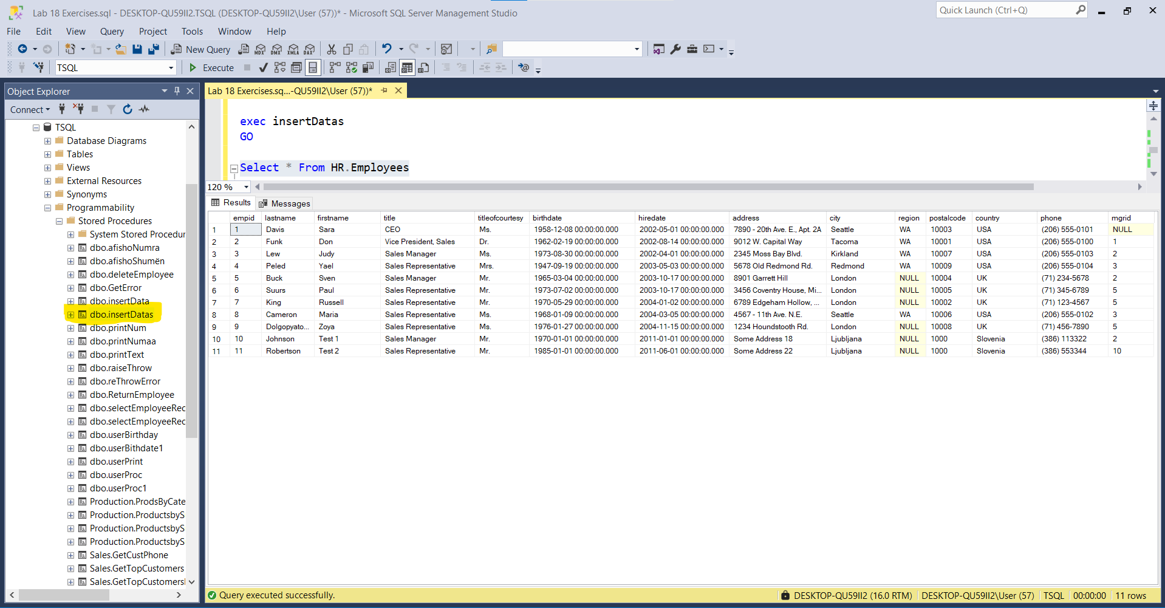

---2--

Select e.lastname , e.firstname , e.empid

From HR.Employees e

--3--

GO

CREATE PROCEDURE insertData3

AS

Begin

BEGIN TRY

BEGIN TRANSACTION

INSERT INTO HR.Employees (lastname, firstname, title, titleofcourtesy, birthdate, hiredate, address,

city, region, postalcode, country, phone, mgrid)

VALUES (N'Johnson', N'Test 1', N'Sales Manager', N'Mr.', '19700101', '20110101', N'Some Address 18',

N'Ljubljana', NULL, N'1000', N'Slovenia', N'(386) 113322', 2);

INSERT INTO HR.Employees (lastname, firstname, title, titleofcourtesy, birthdate, hiredate, address,

city, region, postalcode, country, phone, mgrid)

VALUES (N'Robertson', N'Test 2', N'Sales Representative', N'Mr.', '19850101', '20110601', N'Some Address 22',

N'Ljubljana', NULL, N'1000', N'Slovenia', N'(386) 553344', 10);

COMMIT TRANSACTION

END TRY

Begin CATCH

IF(XACT_STATE() = -1)

BEGIN

PRINT N'An error occurred!It is a user UNCOMMITABLE Transaction.It should be done "ROLLBACK" '

END

SELECT ERROR_MESSAGE() as errMsg,ERROR_SEVERITY() as errSeverity , ERROR_STATE() errState , ERROR_NUMBER() errNumb

ROLLBACK TRANSACTION

END CATCH

END

GO

exec insertData3

go

Select * From HR.Employees

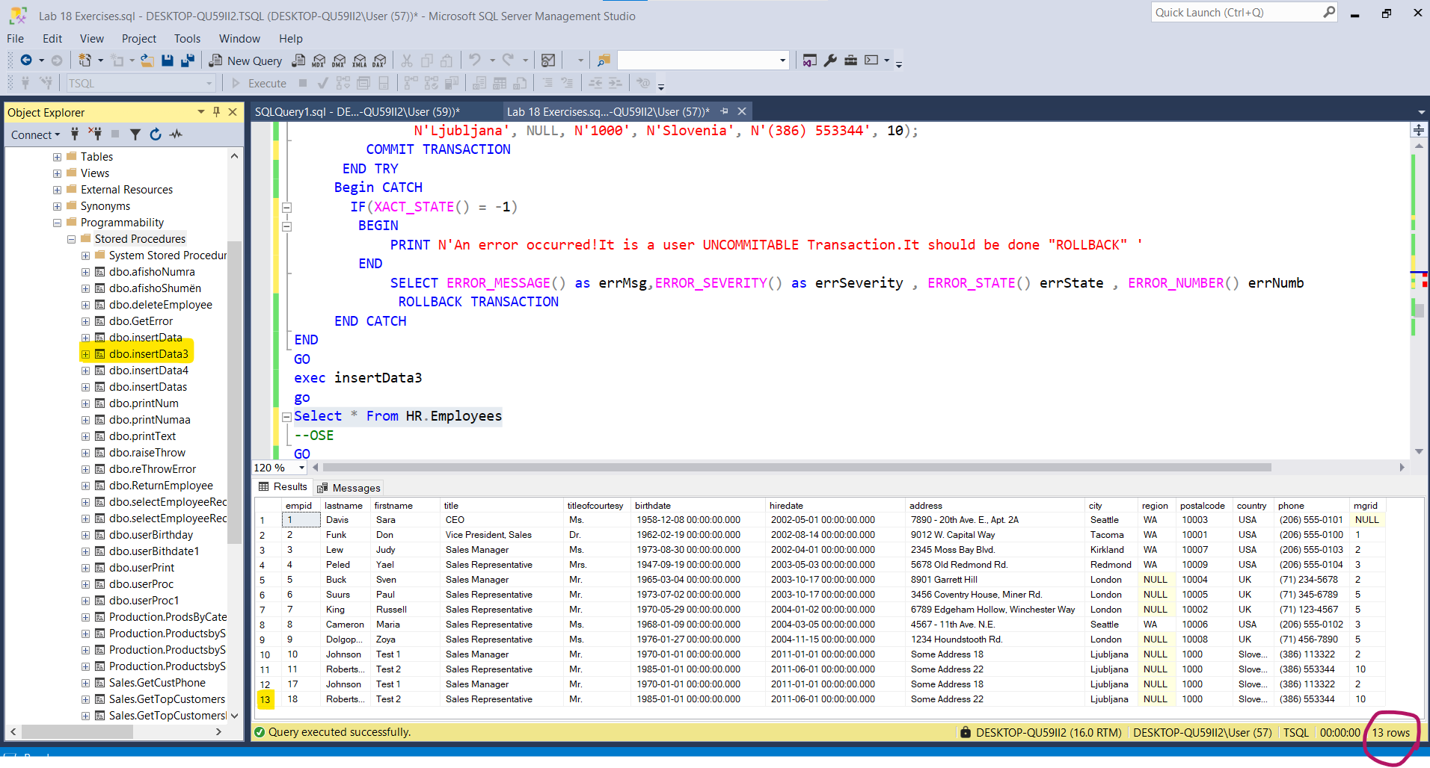

--OSE 'TO CANCEL TRANSACTION' ONLYYY ROLLBACK

GO

CREATE PROCEDURE insertData4

AS

Begin

SET XACT_ABORT ON

PRINT N'An error occurred!It is a user UNCOMMITABLE Transaction.It should be done "ROLLBACK" '

BEGIN TRANSACTION

COMMIT TRANSACTION

END

GO

exec insertData4

go

Select * From HR.Employees

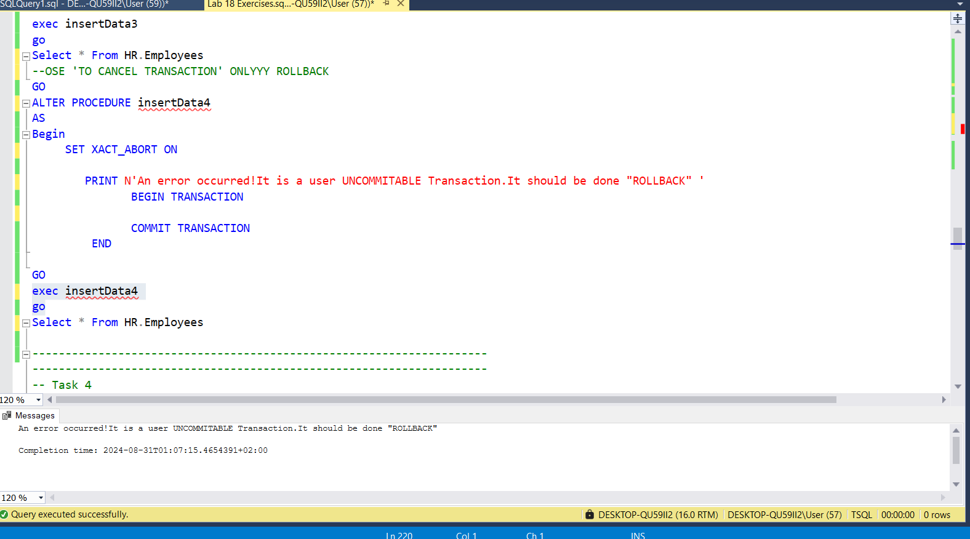

---------------------------------------------------------------------

---------------------------------------------------------------------

-- Task 4

--

-- Execute the provided T-SQL code.

---------------------------------------------------------------------

DBCC CHECKIDENT ('HR.Employees', RESEED, 9);

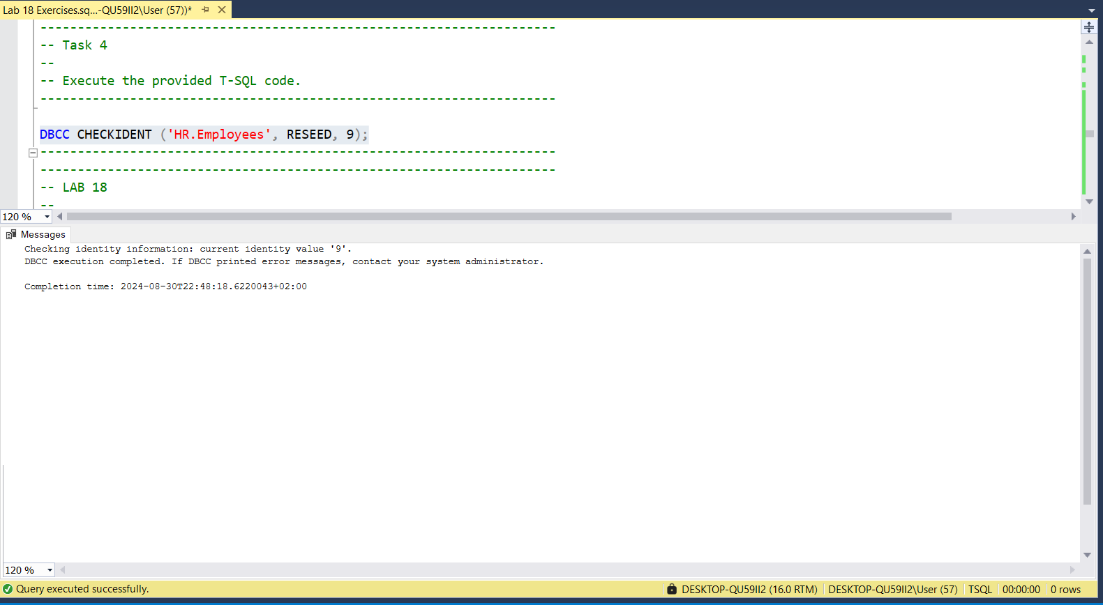

---------------------------------------------------------------------

---------------------------------------------------------------------

-- LAB 18

--

-- copy-paste text about lab from doc file

--

-- Exercise 2

---------------------------------------------------------------------

USE TSQL;

GO

---------------------------------------------------------------------

-- Task 1

--

-- The IT department has provided T-SQL code that is similar to the code in the previous exercise.

-- Execute only the SELECT statement.

SELECT empid, lastname, firstname

FROM HR.Employees

ORDER BY empid DESC;

GO

-- Observe and compare the results that you got with the desired results shown in the file 62

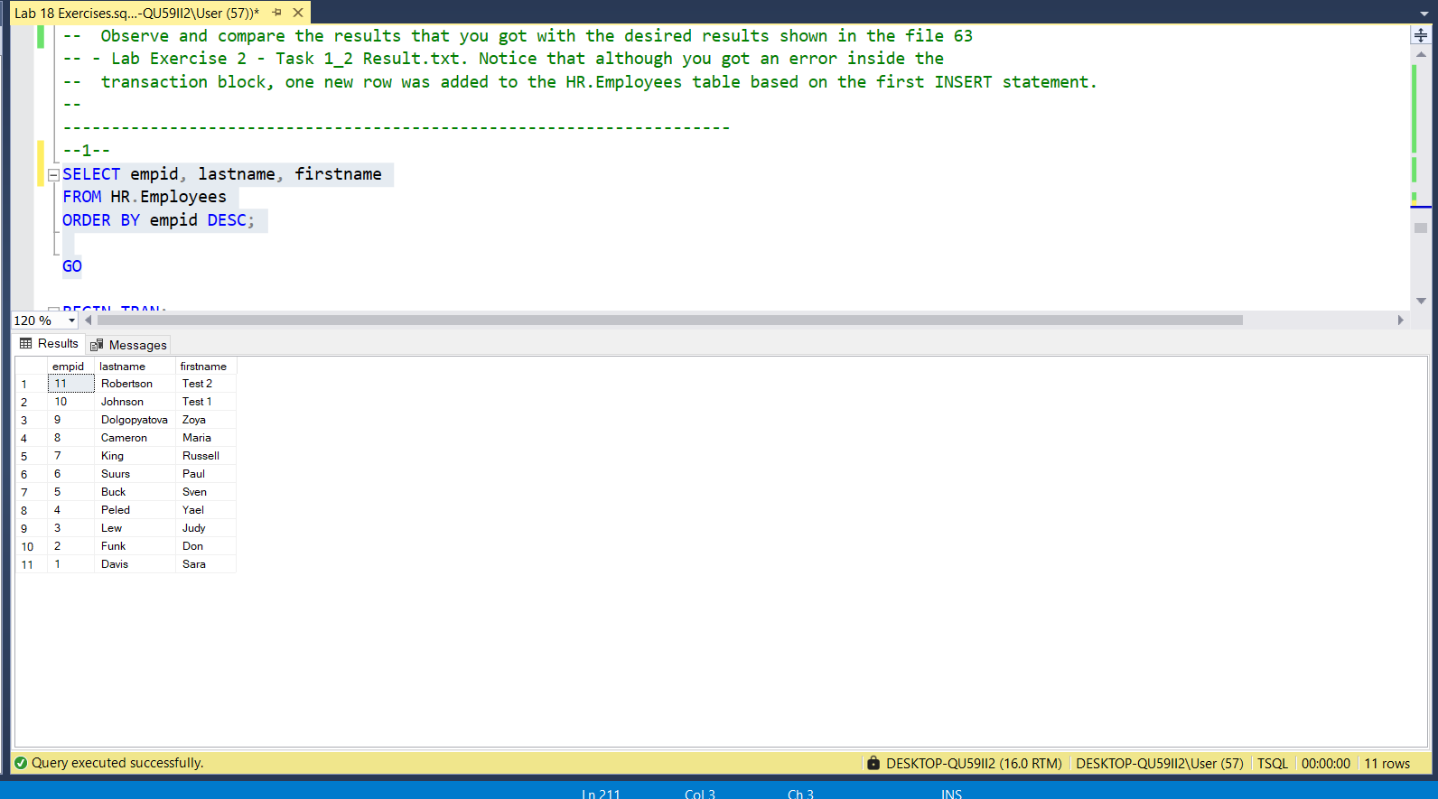

Select * From HR.Employees E

ORDER BY E.empid DESC

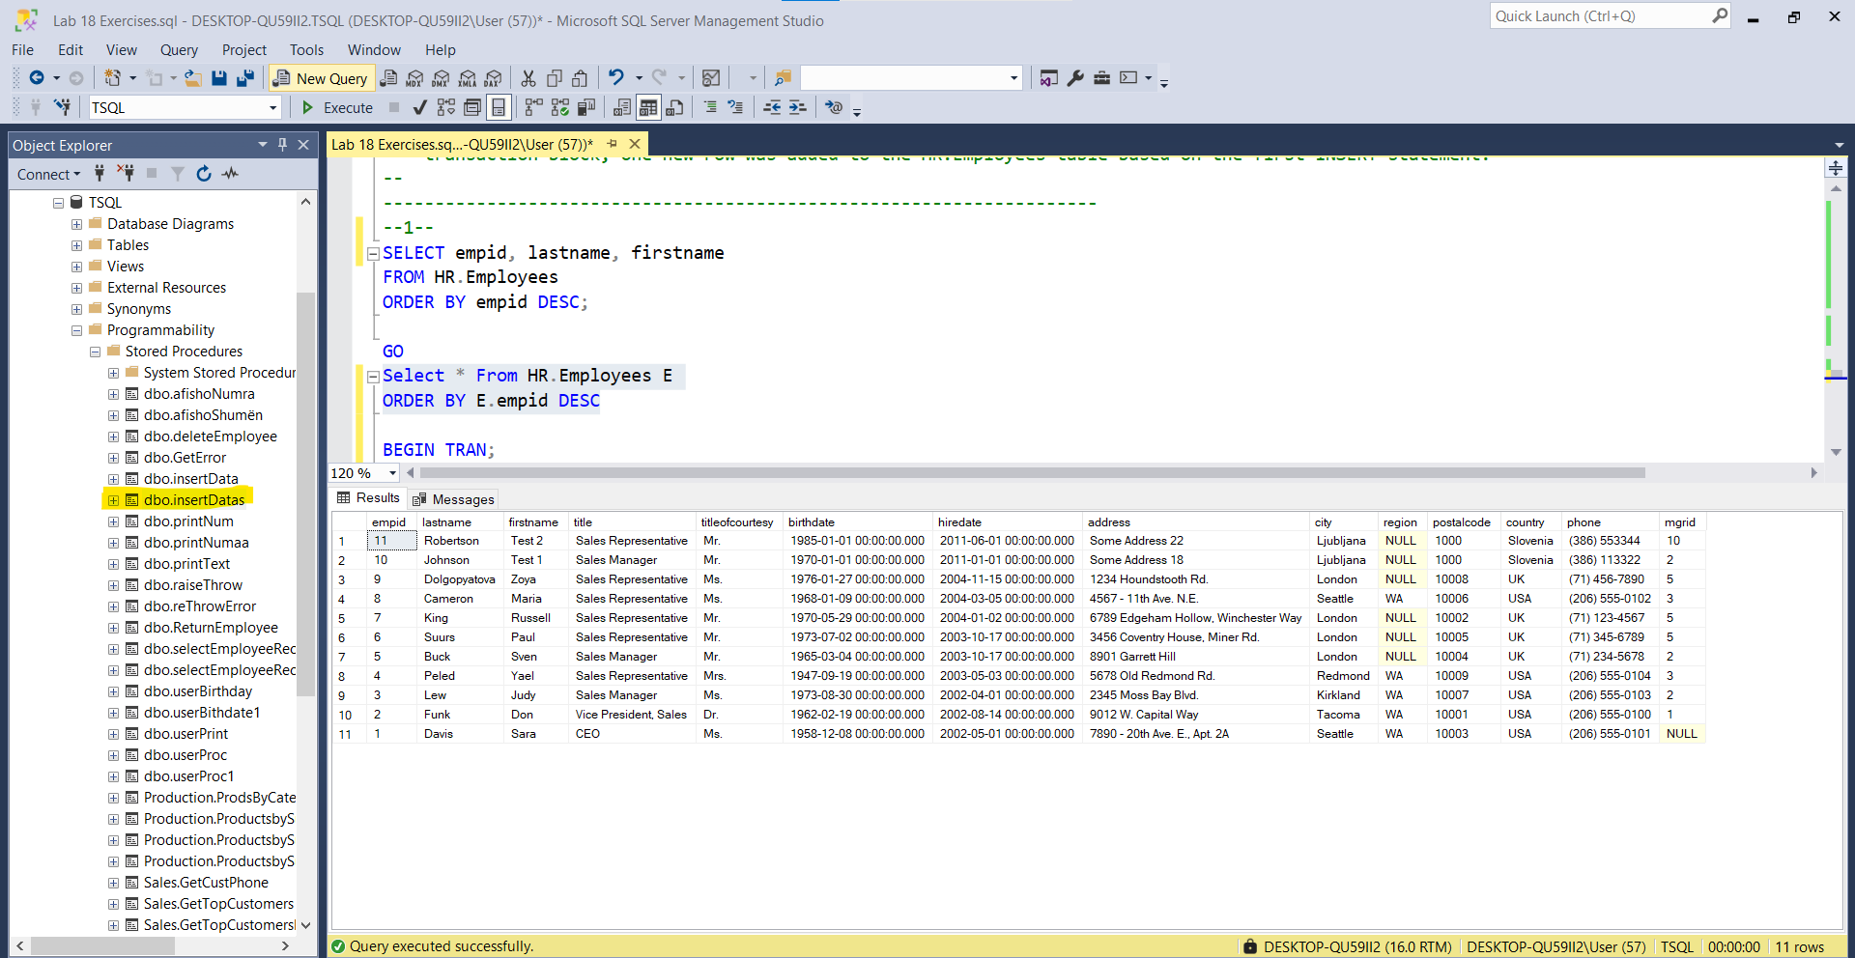

-- - Lab Exercise 2 - Task 1_1 result.txt. Notice the number of employees in the HR.Employees table.

SELECT COUNT(*) AS noEmployee FROM HR.Employees

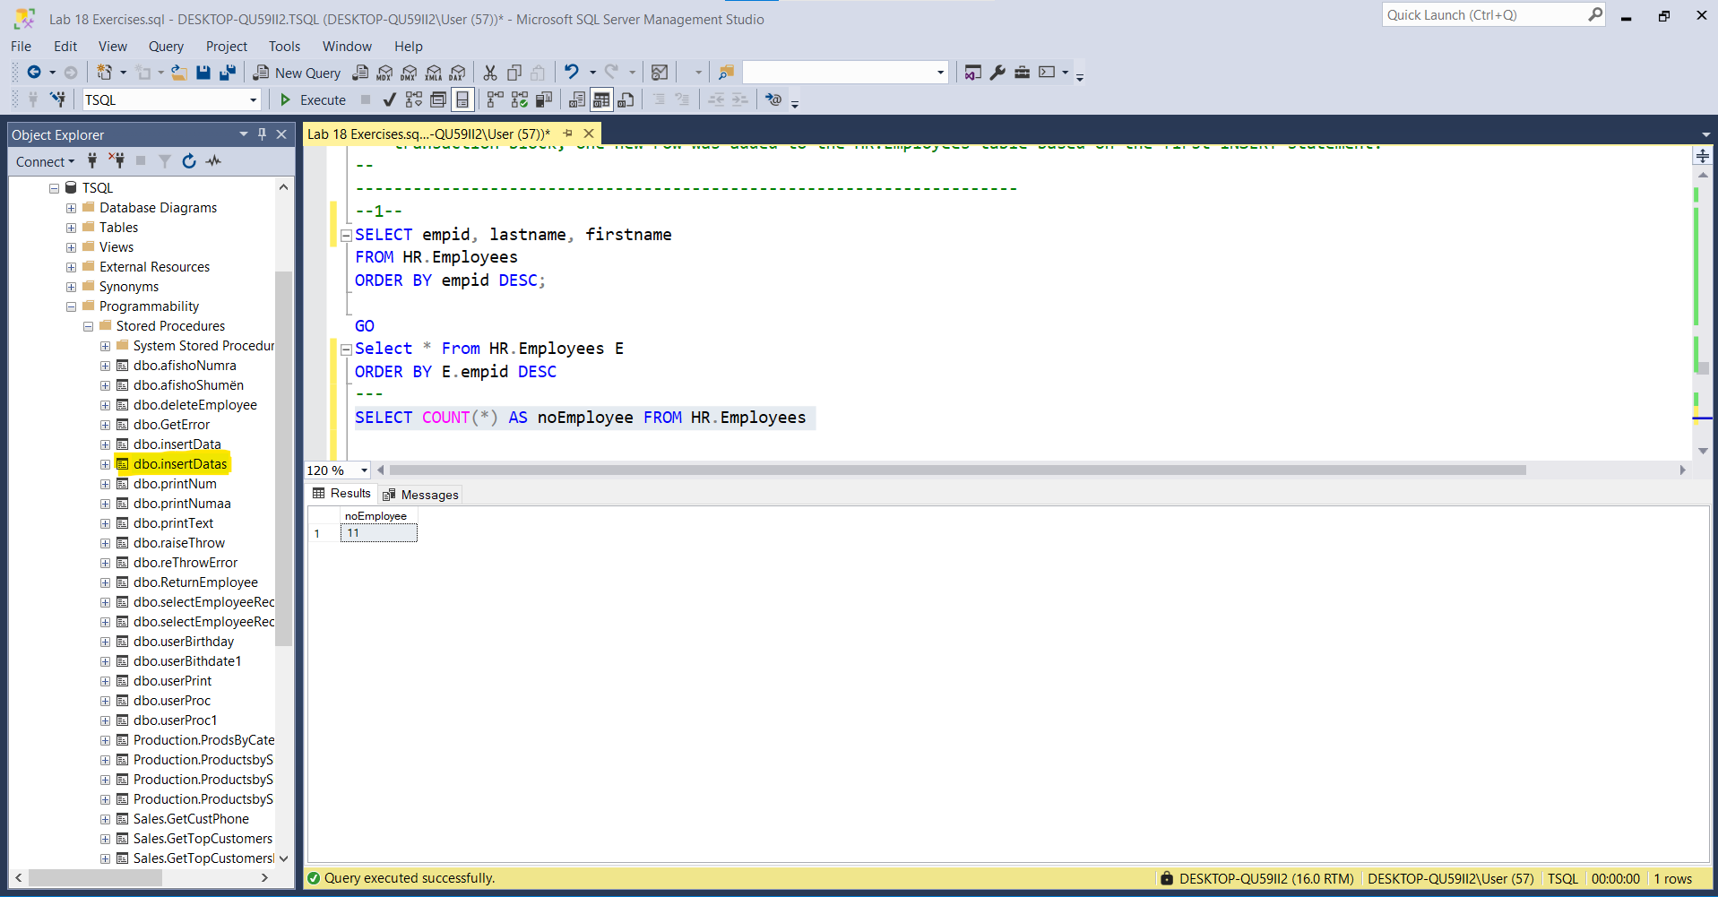

-- Execute the part of the T-SQL code that starts with a BEGIN TRAN statement and ends

with the COMMIT TRAN statement.

BEGIN TRAN;

INSERT INTO HR.Employees (lastname, firstname, title, titleofcourtesy, birthdate, hiredate, address, city, region, postalcode, country, phone, mgrid)

VALUES (N'Johnson', N'Test 1', N'Sales Manager', N'Mr.', '19700101', '20110101', N'Some Address 18', N'Ljubljana', NULL, N'1000', N'Slovenia', N'(386) 113322', 2);

INSERT INTO HR.Employees (lastname, firstname, title, titleofcourtesy, birthdate, hiredate, address, city, region, postalcode, country, phone, mgrid)

VALUES (N'Robertson', N'Test 2', N'Sales Representative', N'Mr.', '19850101', '10110601', N'Some Address 22', N'Ljubljana', NULL, N'1000', N'Slovenia', N'(386) 553344', 10);

COMMIT TRAN;

GO

--You will get a conversion error in the second INSERT statement.

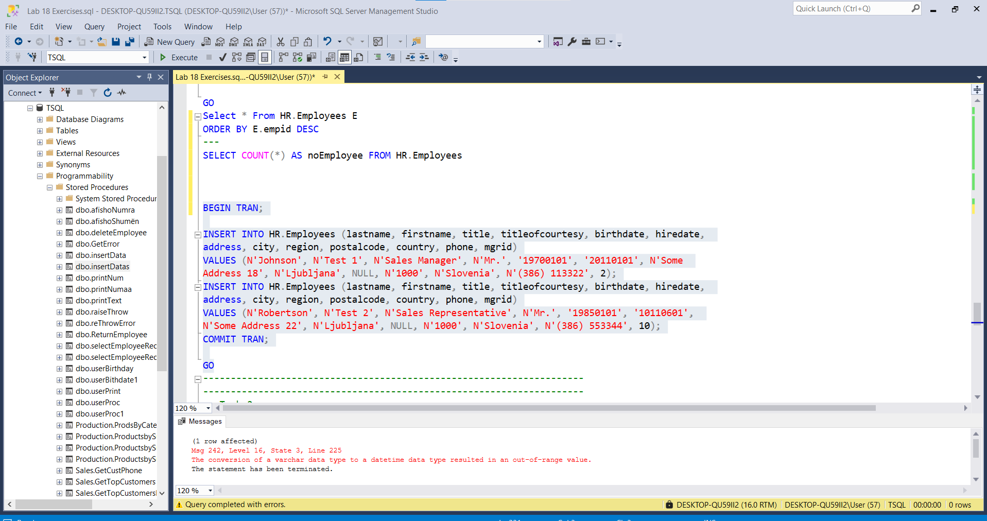

-- Again execute only the SELECT statement.

SELECT empid, lastname, firstname

FROM HR.Employees

ORDER BY empid DESC;

GO

-- Observe and compare the results that you got with the desired results shown in the file 63

-- - Lab Exercise 2 - Task 1_2 Result.txt. Notice that although you got an error inside the

-- transaction block, one new row was added to the HR.Employees table based on the first INSERT statement.

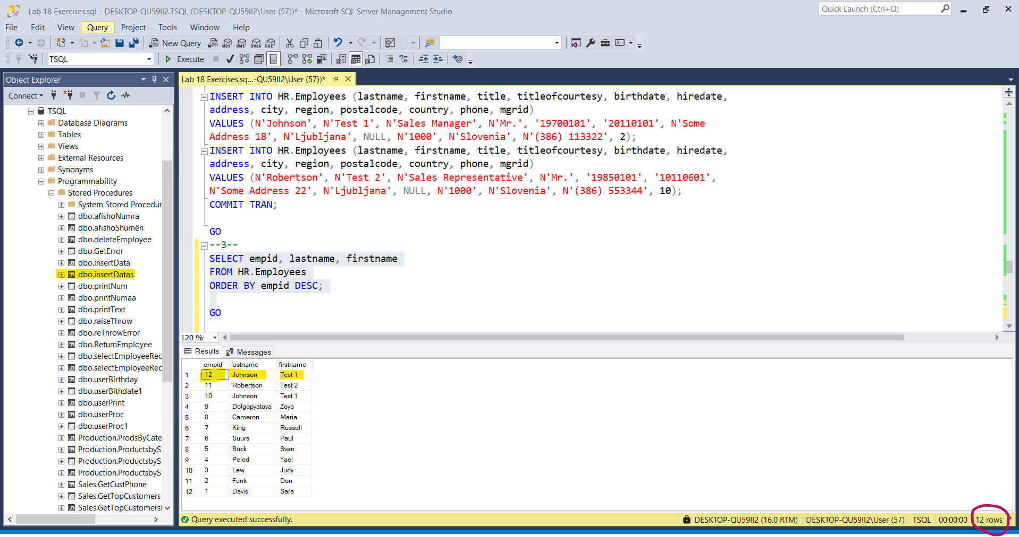

--Eshte shtuar nje rresht me empid = 12

---------------------------------------------------------------------

---------------------------------------------------------------------

-- Task 2

--

-- Execute the provided T-SQL code to delete the row inserted from the previous task.

-- Note that this is a cleanup code that will not be explained in this course.

---------------------------------------------------------------------

DELETE HR.Employees

WHERE empid IN (10, 11);

DBCC CHECKIDENT ('HR.Employees', RESEED, 9);

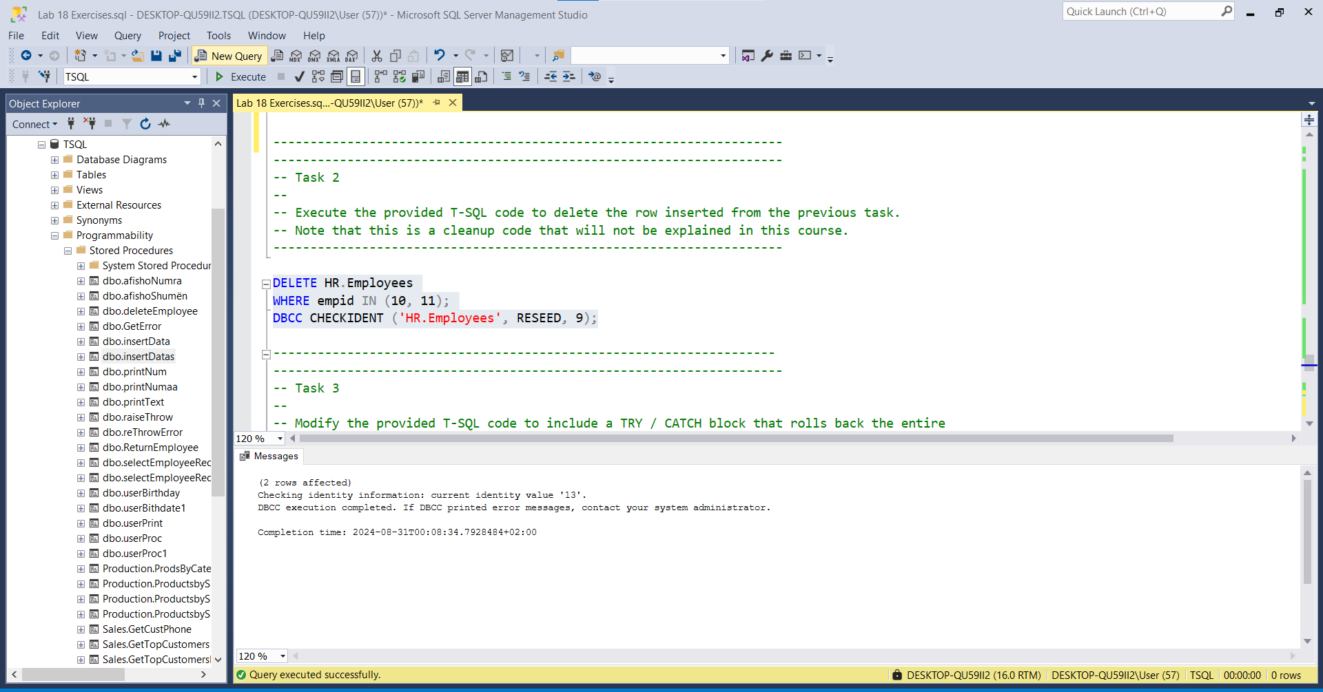

Select * From HR.Employees

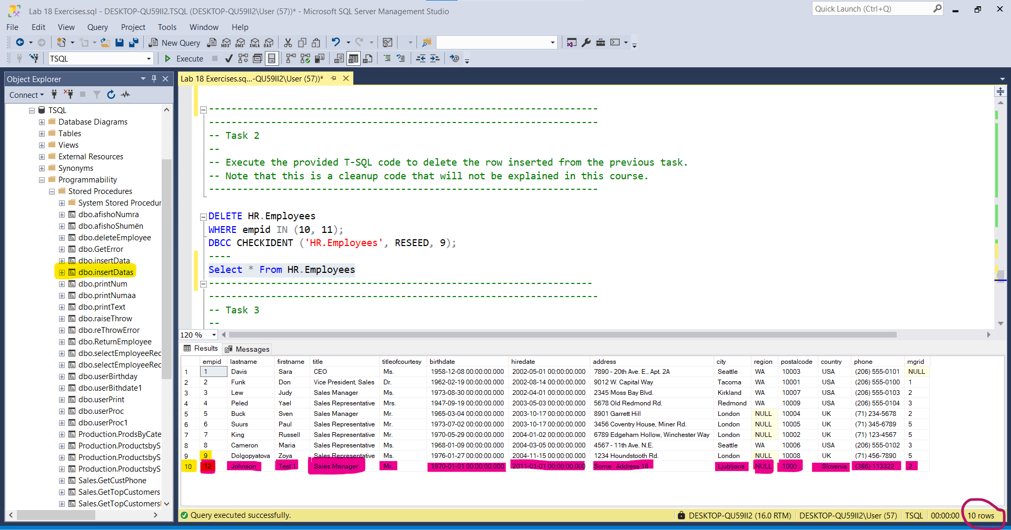

--------------------------------------------------------------------

---------------------------------------------------------------------

-- Task 3

--

-- 1 --Modify the provided T-SQL code to include a TRY / CATCH block that rolls back the entire

-- transaction if any of the INSERT statements throws an error:

-- In the CATCH block, include a PRINT statement that prints the message “Rollback the transaction…”

-- if an error occurred and the message “Commit the transaction…” if no error occurred.

--2-- Execute the modified T-SQL code.

-- Observe and compare the results that you got with the recommended result shown in the file 64

-- - Lab Exercise 2 - Task 3_1 Result.txt.

--3-- Write a SELECT statement against the HR.Employees table to see if any new rows

-- were inserted (like you did in exercise 1). Execute the SELECT statement.

-- Observe and compare the results that you got with the recommended result shown

-- in the file 65 - Lab Exercise 2 - Task 3_2 Result.txt.

---------------------------------------------------------------------

--1--

GO

CREATE PROCEDURE insertDatas5(

@lastname NVARCHAR(20) = 'Johnson',

@firstname nvarchar(10) = 'Test 1',

@title nvarchar(30) = 'Sales Manager',

@titleofcourtesy nvarchar(25) = 'Mr.',

@birthday datetime = '19700101',

@hiredate datetime = '20110101',

@address nvarchar(60)='Some Address 18',

@city nvarchar(15)='Ljubljana',

@region nvarchar(15) = 'null',

@postalcode nvarchar(10) = '1000',

@country nvarchar(15) = 'Slovenia',

@phone nvarchar(24) = '(386) 113322' ,

@mgrid int = 2

)

AS

BEGIN

BEGIN TRY

BEGIN TRANSACTION

INSERT INTO HR.Employees (lastname, firstname, title,

titleofcourtesy, birthdate, hiredate,

address, city, region, postalcode, country, phone, mgrid)

VALUES (@lastname, @firstname, @title,@titleofcourtesy,

@birthday, @hiredate,@address,@city, @region, @postalcode,

@country, @phone, @mgrid);

-- INSERT INTO HR.Employees (lastname, firstname, title, titleofcourtesy, birthdate, hiredate,

-- address, city, region, postalcode, country, phone, mgrid)

-- VALUES (N'Robertson', N'Test 2', N'Sales Representative', N'Mr.', '19850101', '10110601',

-- N'Some Address 22', N'Ljubljana', NULL, N'1000', N'Slovenia', N'(386) 553344', 10);

COMMIT TRANSACTION

END TRY

BEGIN CATCH

IF(XACT_STATE() = -1)

BEGIN

PRINT N'An error occurred,RollBack Transaction...'

END

ELSE IF(XACT_STATE() = 1)

BEGIN

PRINT N'A user commitable transaction is waiting,COMMIT TRANSACTION...'

END

ELSE IF(XACT_STATE() = 0)

BEGIN

PRINT N'No action needed!'

END

ELSE

BEGIN

PRINT N''

END

ROLLBACK TRANSACTION

END CATCH

END

GO

Commands completed successfully.

Completion time: 2024-08-31T11:31:30.1240443+02:00

--2--

EXECUTE insertDatas5

GO

(1 row affected)

Completion time: 2024-08-31T12:49:13.2851565+02:00

--Kontrollojme nese eshte shtuar rekordi

SELECT * FROM HR.Employees

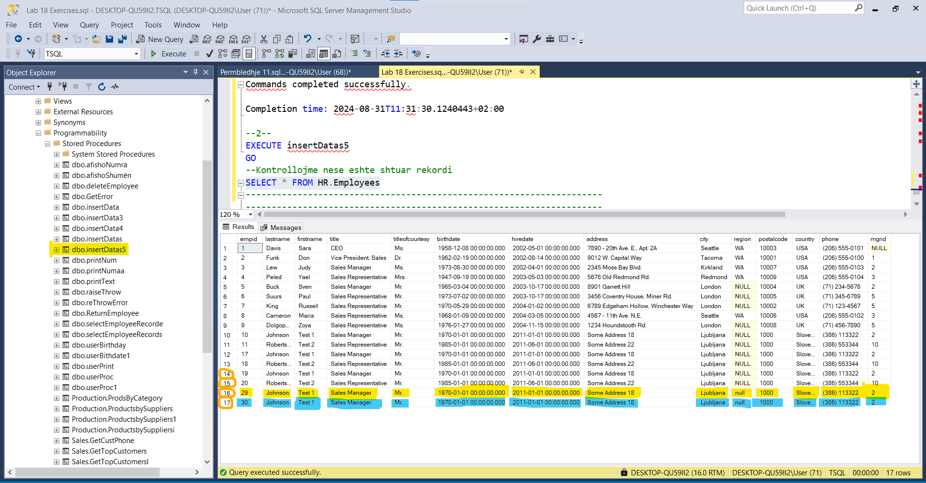

--Insertojmë rreshtin e dytë

GO

ALTER PROCEDURE insertDatas5(

@lastname NVARCHAR(20) ,

@firstname nvarchar(10) ,

@title nvarchar(30) ,

@titleofcourtesy nvarchar(25),

@birthday datetime ,

@hiredate datetime ,

@address nvarchar(60),

@city nvarchar(15),

@region nvarchar(15) ,

@postalcode nvarchar(10) ,

@country nvarchar(15) ,

@phone nvarchar(24) ,

@mgrid int

)

AS

BEGIN

BEGIN TRY

BEGIN TRANSACTION

INSERT INTO HR.Employees (lastname, firstname, title,

titleofcourtesy, birthdate, hiredate,address, city, region,

postalcode, country, phone, mgrid)

VALUES (@lastname, @firstname, @title,@titleofcourtesy,

@birthday, @hiredate,@address,@city, @region, @postalcode,

@country, @phone, @mgrid);

COMMIT TRANSACTION

END TRY

BEGIN CATCH

IF(XACT_STATE() = -1)

BEGIN

PRINT N'An error occurred,RollBack Transaction...'

END

ELSE IF(XACT_STATE() = 1)

BEGIN

PRINT N'A user commitable transaction is waiting,COMMIT TRANSACTION...'

END

ELSE IF(XACT_STATE() = 0)

BEGIN

PRINT N'No action needed!'

END

ELSE

BEGIN

PRINT N''

END

ROLLBACK TRANSACTION

END CATCH

END

GO

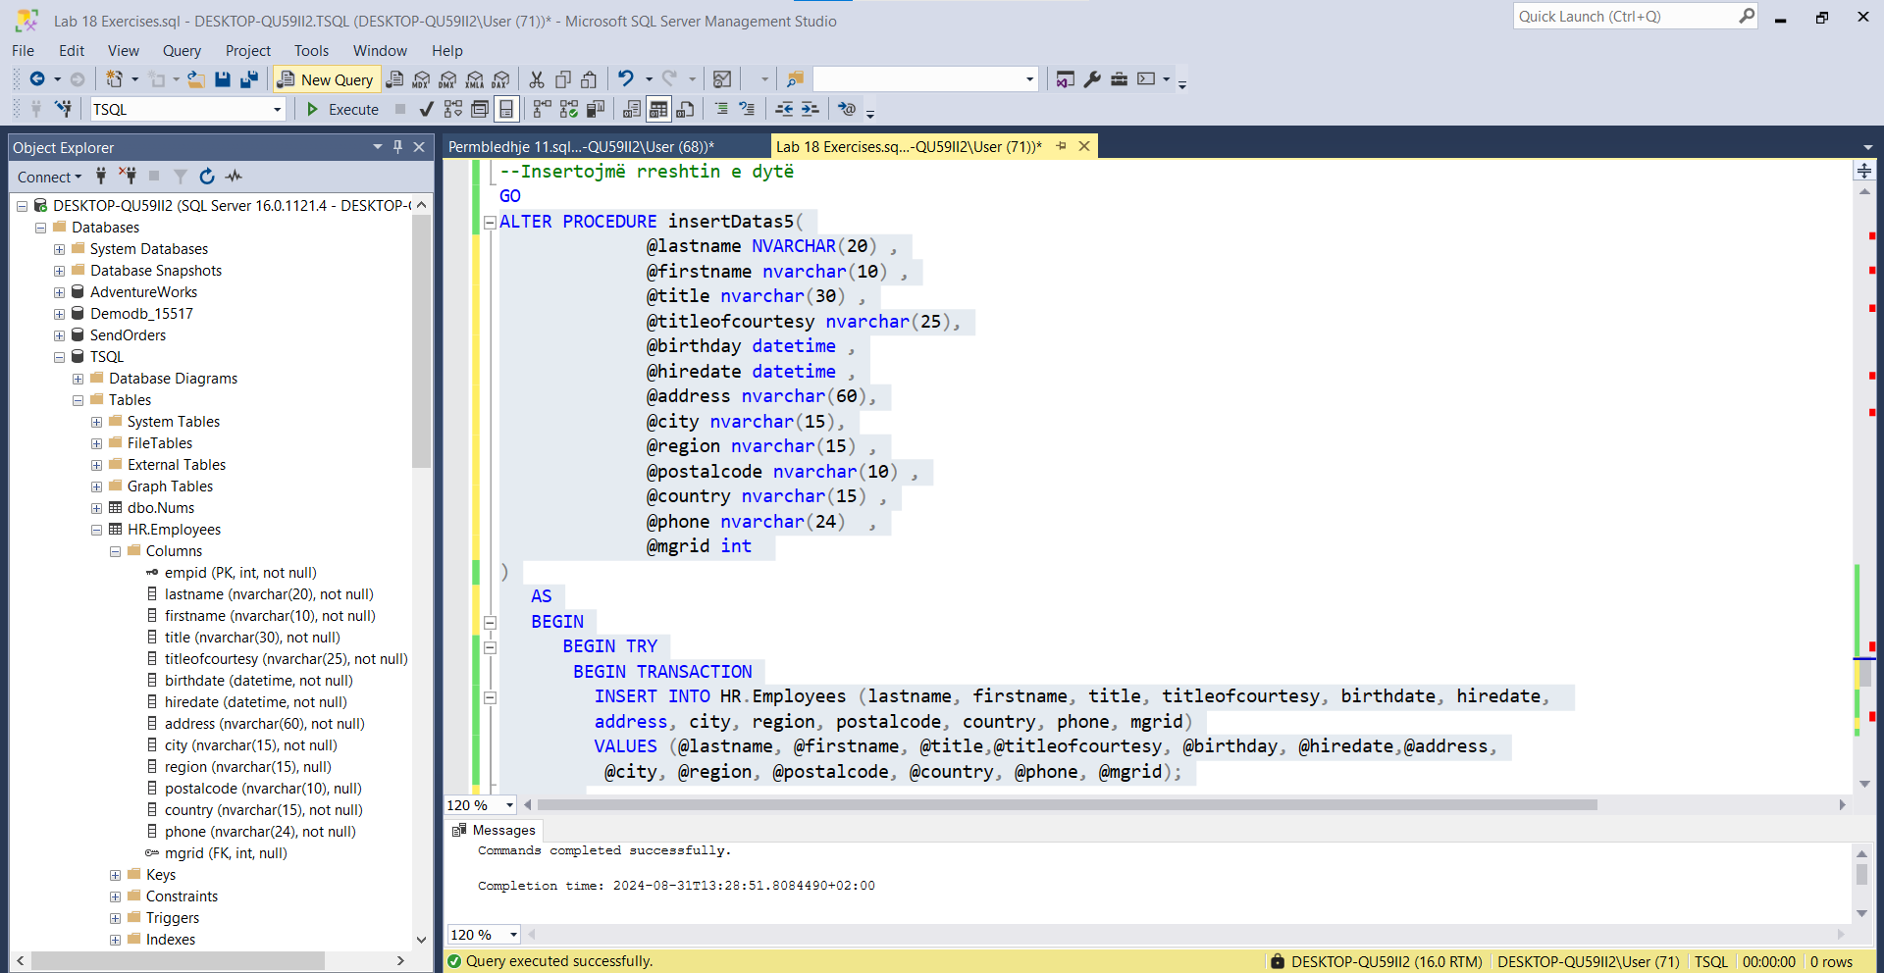

EXECUTE insertDatas5 @lastname = N'Robertson' , @firstname = N'Test 2',@title = N'Sales Representative',@titleofcourtesy = N'Mr.' , @birthday = '1985-01-01',@hiredate = '2011-06-01',@address = N'Some Address 22' , @city = N'Ljubljana',@region = 'NULL', @postalcode = N'1000' ,@country = N'Slovenia' ,@phone = N'(386) 553344',@mgrid = 10

GO

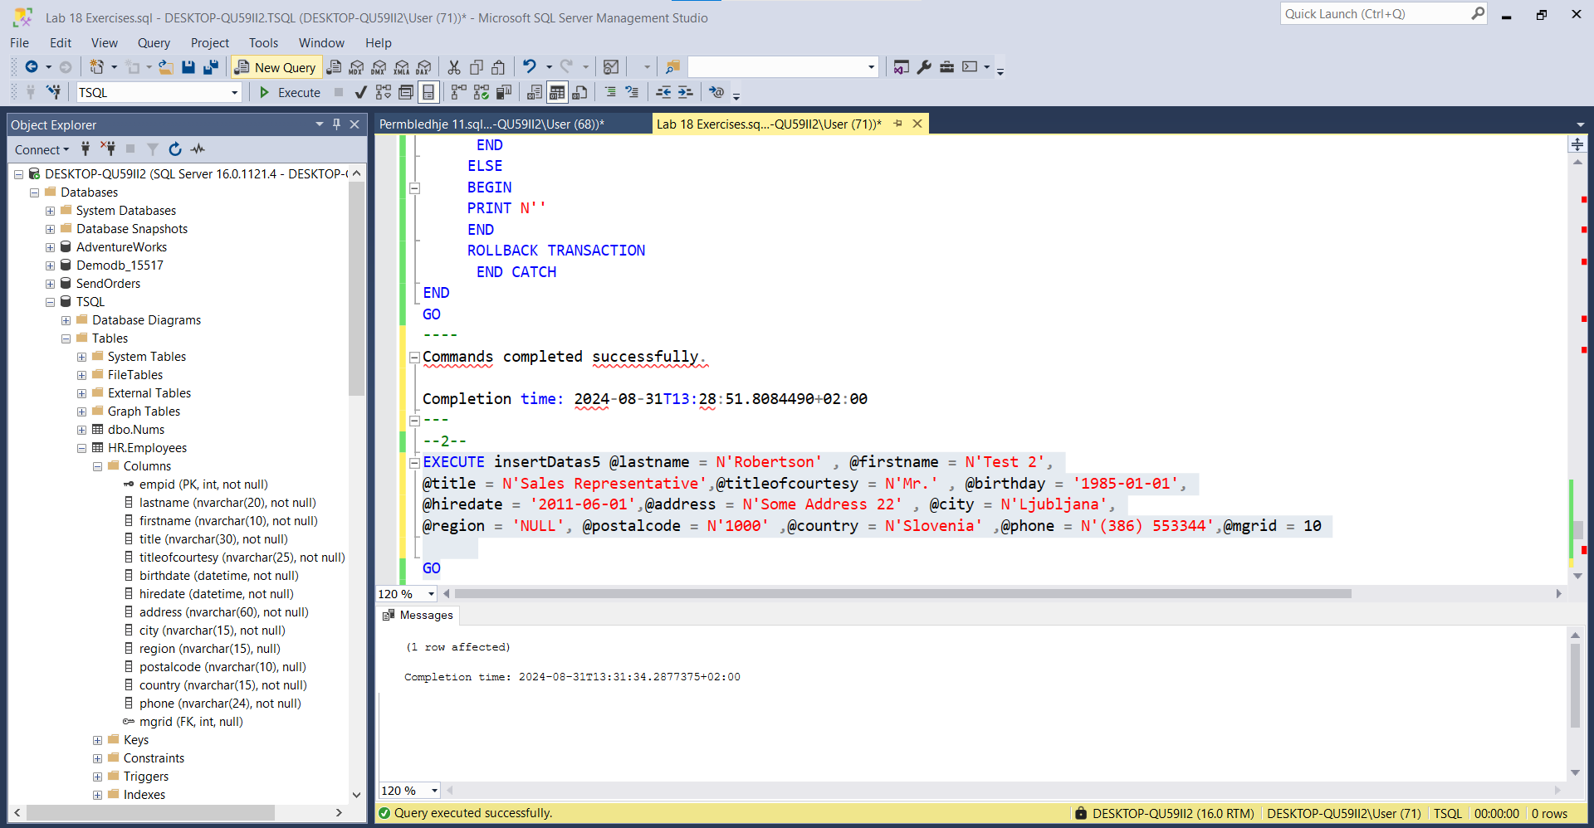

Select * From HR.Employees

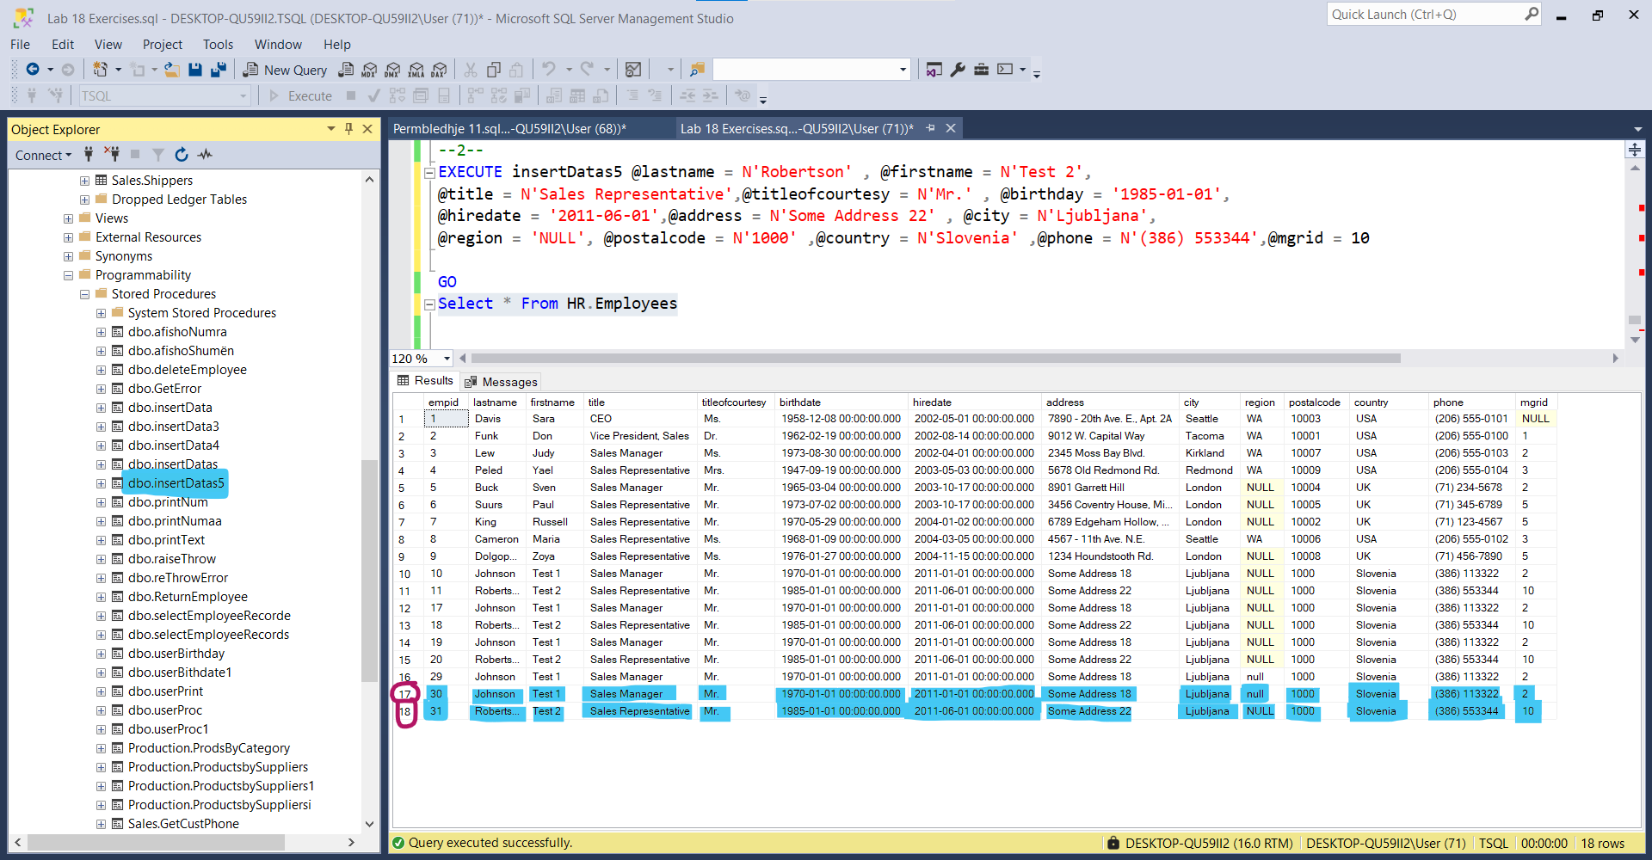

***Nëse tentojmë serisht të ekzekutojmë të njëjtin statement

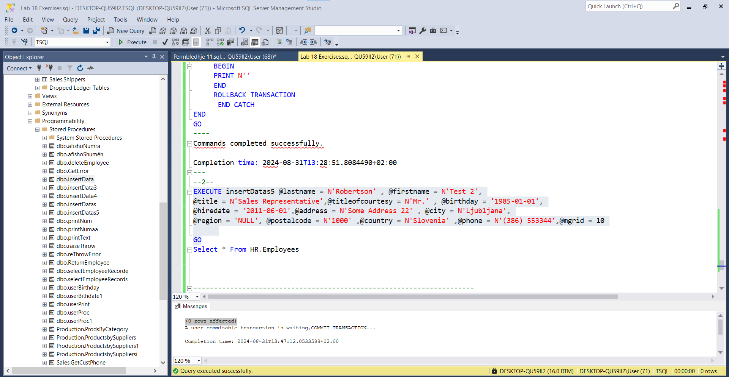

(0 rows affected)

A user commitable transaction is waiting,COMMIT TRANSACTION...

Completion time: 2024-08-31T13:48:29.7605449+02:00

---------------------------------------------------------------------------------------

-- Task 4

--

-- Execute the provided T-SQL code.

---------------------------------------------------------------------

DBCC CHECKIDENT ('HR.Employees', RESEED, 9);

---------------------------------------------------------------------

